**PLANNING PROPOSAL**

**FOR  
OATLANDS GOLF CLUB LAND FACING NIBLICK CRESCENT, (BETWEEN NO. 17 AND NO. 21) OATLANDS**

*Date: 16th November 2015*

Contents

**INTRODUCTION** 3

**INTENDED OUTCOMES** 4

**PROPOSED COMMUNITY CONSULTATION** 5

**EXPLANATION OF PROVISIONS** 7

**JUSTIFICATION** 10

**RELATIONSHIP TO STRATEGIC PLANNING FRAMEWORK** 11

**ENVIRONMENTAL, SOCIAL AND ECONOMIC IMPACT** 15

**CONCLUSION** 17

**APPENDIX A – OVERLAND FLOW MANAGEMENT STUDY REPORT** 18

# **INTRODUCTION**

**The Subject Site**

The subject site is that part (2310 square metres) of the Oatlands Golf Club land (Lot 39 DP 808581) with a frontage of 57.35 metres to Niblick Crescent (between Number 17 and Number 21 Niblick Crescent Oatlands) and a depth of between 31.15 metres and 36.575 metres from the Niblick Crescent frontage. The subject site currently contains no improvements apart from some log barriers to prevent vehicles entering the site. The site contains no other improvements and does not contain stands of significant vegetation nor does the site contain any threatened species.

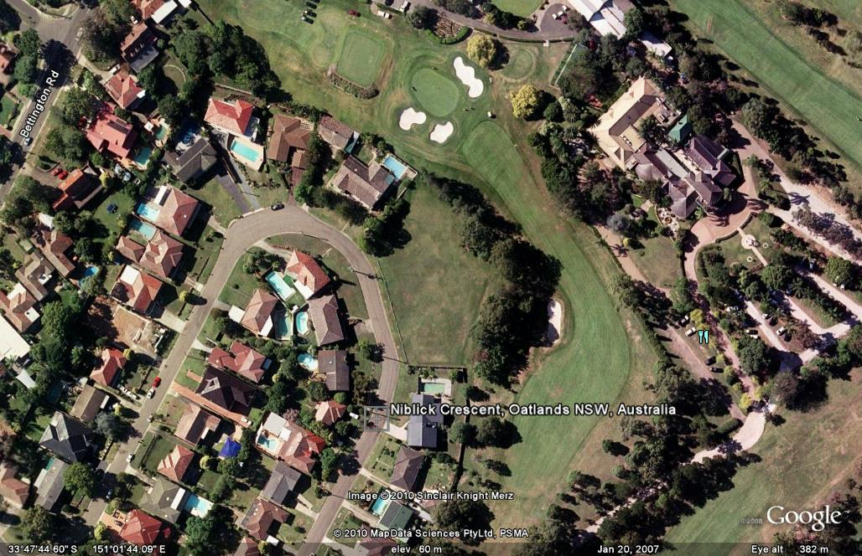

Subject site area under consideration

The subject site slopes from a high point of RL60.45 metres in the north-eastern corner of the site to a low point of 52.36 metres AHD in the south-western corner of the site facing Niblick Crescent.

The site is generally consistent in its fall across the site towards Niblick Crescent.

The subject site is not believed to contain any hazardous material nor is the site believed to contain any significant degree of filling. The site is believed to be geotechnically stable and is not subject to flooding, bushfire or tidal inundation, nor does the site contain any threatened or endangered species.

Surrounding the site to the north is the remainder of the Golf Club land separated from the subject site by a narrow band of vegetation and containing Oatlands House, a heritage item identified under the Parramatta Local Environmental Plan 2011.

The remainder of Niblick Crescent is zoned R2 Low Density Residential under the Parramatta Local Environmental Plan 2011 with the surrounding housing stock in Niblick Crescent currently undergoing a significant degree of redevelopment with many of the original dwellings being demolished and redeveloped and several others undergoing major renovations.

# **INTENDED OUTCOMES**

The intended outcome of this planning proposal is to rezone the existing part of Oatlands Golf Course fronting Niblick Crescent from the current zoning designated as RE2 (Private Recreation) under the Provisions of Parramatta Local Environmental Plan 2011 (PLEP 2011) to R2 (Low Density Residential) to permit the use of this part of Oatlands Golf Club for future residential subdivision.

The proposal also seeks the imposition of the relevant Development Standards under the provisions of the Parramatta Local Environmental Plan 2011, namely the provisions of *Part 4 Principal development standards* of the Parramatta Local Environmental Plan 2011.

Achievement of this outcome will enable redevelopment of that part of the subject site facing Niblick Crescent in accordance with the following objectives of the Low Density (R2) Residential Zone:-

1. *To provide for the housing needs of the community within a low density residential environment.*
2. *To enable other land uses that provide facilities or services to meet the day to day needs of residents.*
3. *To ensure that non-residential land uses are located in a context and setting that minimises impacts on the amenity of a low density residential environment.*
4. *To allow for a range of community facilities to be provided to serve the needs of residents, workers and visitors in residential neighbourhoods.*

The proposed zoning to R2 (Low Density Residential) will render the following uses permissible with consent on the subject site:-

*Bed and Breakfast accommodation; boarding houses; building identification signs; business identification signs; community facilities; dual occupancy; dwelling houses; educational establishments; emergency service facilities; environmental facilities; environmental protection works; exhibition homes; exhibition villages; flood mitigation works; group homes; home based childcare; home businesses; home industry; hospitals; hostels; neighbourhood shops; public administration buildings; recreation areas; recreation facilities (indoor); recreation facilities (outdoor); roads; seniors housing; water recycling facilities.*

The intended outcome is to allow this part of the subject site which is currently underutilised by the Oatlands Golf Club to be used for residential purposes under the provisions of the R2 (Low Density Residential) Zone as prescribed under the Parramatta Local Environmental Plan 2011.

To assist in achieving this outcome, the site has been investigated by Benbow Environmental who has prepared a Phase 1 Contamination Investigation (attached). This site investigation concludes that as there was no evidence of any site contamination, no further investigation is warranted.

# 

# **PROPOSED COMMUNITY CONSULTATION**

Community consultation is to be carried out in accordance with Parramatta Councils adopted principles of community consultation, in particular, Councils Community Stakeholder Engagement Policy.

In addition, the Applicant, namely Oatlands Golf Club, is able to conduct information sessions for interested members of the local community if required. This was conducted previously and provided information to neighbouring landholders.

Indicative Subdivision Layout

# **EXPLANATION OF PROVISIONS**

The Planning Proposal seeks the following amendments to the Parramatta Local Environmental Plan 2011 for the subject land.

1. Rezone from RE2 Private Recreation to R2 Low Density Residential (R2)
2. Introduce a maximum Height of Building control of 9m (J1).
3. Introduce a maximum Floor Space Ratio of 0.5:1 (D)
4. Introduce a minimum Lot Size control of 550 square metres (K)

Maps illustrating the proposed amendments are provided on the following pages. It should be noted that the proposed planning controls are entirely consistent with the controls imposed upon the remainder of Niblick Crescent.

|  |  |  |
| --- | --- | --- |
| **Key** | **Current Land Zoning Map** | **Proposed Land Zoning Map** |
|  |  | **R2** |
|  | **Current Height Map** | **Proposed Height Map** |
|  |  | **J1** |
|  | **Current Floor Space Ratio Map** | **Proposed Floor Space ratio Map** |
|  |  | **D** |
|  | **Current Lot Size Map** | **Proposed Lot Size Map** |
|  |  | **K** |

# **JUSTIFICATION**

**Need for the Planning Proposal**

1. **Is the planning proposal a result of any strategic study or report?**

This planning proposal has been prepared as a consequence of the West Central Sub-Regional Strategy and Parramatta Council’s Residential Development Strategy which identifies a number of key sites throughout the Parramatta City Area which are worthy of additional consideration for residential development of varying densities.

The Residential Development Strategy states that the “guiding principle of the Residential Development Strategy is for most residential growth to be concentrated in areas close to public transport, shops and services”. The subject site is ideally situated in close proximity to public transport being bus services on Bettington Road, shops and services in the form of convenience stores with associated commercial uses in the Bettington Road Shopping Centre situated in close proximity to the subject site.

1. **Is the Planning Proposal the best means of achieving the objectives or intended outcomes, or is there is a better way?**

This planning proposal seeks to change the controls on development from Private Recreation (Golf Course) to provide for Low Density Residential Accommodation on an area of the subject site which is significantly under-utilised and has been for many years. The proposal constitutes infill development, consistent with the remaining subdivision pattern of Niblick Crescent surrounding the subject site.

1. **Is there a Net Community Benefit?**

The planning proposal, if supported will result in improvements to the urban environment by enabling the facilitation of residential development on a site that is currently under utilised.

The subject site by virtue of its typography and location is ideally suited to residential development which will facilitate the following outcomes:-

* Provide for high quality, well designed urban housing which will be consistent with the currently evolving urban form of Niblick Crescent and the surrounding locality.
* Enable new housing to be provided in a locality which will facilitate the support of local businesses.
* Enable urban development which will incorporate energy efficient designs, water conservation and higher standards of environmental performance than the existing urban form in the nearby locality.
* The granting of approval for the proposed rezoning will facilitate the provision of improved drainage infrastructure to the subject land and surroundings to improve the current situation of excessive overland flow.

The proposal will also facilitate Council being able to meet its housing targets imposed by the Metropolitan Strategy and subsequent strategies and studies in a manner that does not result in the loss of any existing housing stock.

# **RELATIONSHIP TO STRATEGIC PLANNING FRAMEWORK**

1. **Is the Planning Proposal consistent with the Objectives and Actions contained within the Applicable Regional or Sub-Regional Strategy (including the Sydney Metropolitan Strategy and Exhibited Draft Strategies)?**

The Proposal is consistent with Metropolitan Strategy (2005), the draft West Central Sub-Regional Strategy and Council’s Residential Development Strategy.

The Metropolitan Strategy envisages that –

*“The river cities of Parramatta, Liverpool and Penrith will provide a focus for innovative business environments, jobs and more lifestyle and work opportunities close to growing parts of Sydney. These centres will attract new shopping, health, education, business and cultural facilities.”*

The Metropolitan Strategy also sought fair access to housing, jobs, services and open space by –

*Improved suburban centres and neighbourhoods will provide healthier environments and access to high quality and suitable housing, jobs, transport choices and open space. A mix of housing types, parks and public places will be available in different locations across the region. Development will be limited in suburban neighbourhoods to protect local character.*

The housing component of the Metropolitan Strategy indicated that Sydney’s population will grow by around 1.1 million by 2031 and states that –

***Over three quarters of new housing will be located in strategic centres, smaller centres,*** ***and corridors within walking distance of shops, jobs and other services concentrated around public transport nodes. As housing density increases in these places the character of Sydney suburbs will be protected.***

The vision of the Metropolitan Strategy was bolstered by themes that the growth of urban areas should be constrained to protect the natural environment with smarter urban planning and development.

The West Central Subregion was identified under the Metropolitan Strategy as having a target of 95,500 additional homes within the West Central Subregion to 2031 to accommodate the needs of the existing population. The submission endorses the future residential growth vision of the Metropolitan Strategy by advising that over the next 10 years, the majority of future dwelling growth will be located in centres with good public transport. Given that there are no Greenfield sites left within the subregion, most of the future dwelling growth will be located within centres (transit nodes) or through infill development.

The proposal for the rezoning of that part of the Golf Club land fronting Niblick Crescent satisfies the criteria in that it now reflects the challenges that have emerged since the publication of the Metropolitan Strategy in 2005 to accommodate the forecast growth of the area to accommodate 6 million people by 2036, an increase of 1.7 million people from 2006.

The following attributes of the proposal endorse its suitability as a Low Density Residential zone.

* The proposal is for “infill development” on a site that is suitable for residential development as it is free from natural hazards such as flooding, bushfire and landslip.
* The site is located within walking distance of public transport and local shops.
* Any additional traffic generated by the proposal is able to be satisfactorily integrated into the surrounding locality by virtue of the sites proximity to Bettington Road.
* Future development on the site will avail itself of existing services and infrastructure already servicing the locality.
* The proposal will not erode the heritage value of Oatlands House, due to the spatial separation of the site and the Oatlands House site.
* The proposal will be entirely consistent with the remainder of the Niblick Crescent locality.

1. **Is the Planning Proposal consistent with the Local Council’s Community Strategic Plan, or other Local Strategic Plan?**

This planning proposal is consistent with Parramatta Council’s Residential Development Strategy which forms the basis of the current Parramatta Local Environmental Plan 2011. This plan seeks to provide for housing growth around public transport and local service centres.

1. **Is the Planning Proposal Consistent with Applicable State Environmental Planning Policies?**

The following State Environmental Planning Policies are relevant to the planning proposal.

|  |  |  |  |
| --- | --- | --- | --- |
| **SEPP** | **Requirement** | **Planning Proposal** | **Comply?** |
| SEPP 32 – Urban Consolidation | The Minister must, when considering the making of environmental planning instruments relating to urban land, implement the aims and objectives of this Policy to the fullest extent practicable. | The planning proposal is consistent with SEPP 32 in providing the opportunity for the development of additional housing in an area where there is existing public infrastructure, transport and community facilities, close to employment, leisure and other opportunities. | Yes |
| SEPP 55 – Remediation of Land | SEPP 55 requires consent authority to consider the possibility that a previous land use may have created contamination of the site as well as the potential risk to health or the environment from that contamination. | The use of the land is unlikely to have resulted in any contamination of the subject site. | Yes, see attached Benbow Report |
| SEPP (BASIX) 2004 | The aim of this Policy is to ensure consistency in the implementation of the BASIX scheme throughout the state. | Detailed compliance with BASIX will be demonstrated at the time of making an application for any residential development of the subject site. | Yes |
| SREP (Sydney Harbour Catchment) | The SREP now have the status of a deemed SEPP. The SREP aims to:  protect the health of the catchment;  protect the operation of any natural drainage systems;  protect and enhance the visual quality of the river;  protect foreshore access to the waterways;  provide suitable management of water quality and management of water quality and management of urban run-off. | The Planning Proposal is consistent with this policy. | Yes |

1. **Is the Planning Proposal consistent with Applicable Ministerial Directions (S.117 Directions)?**

|  |  |  |  |
| --- | --- | --- | --- |
| **S.117 Direction No. and Title** | **Contents of S117 Direction** | **Planning Proposal** | **Comply?** |
| 2.3 Heritage Conservation | Planning proposal must facilitate conservation of the places of heritage significance. | Site is adjacent to a heritage item (Oatlands House) and initial assessment by the applicants’ heritage adviser reveals no likely adverse impact. | Yes |
| 3.1 Residential Zones | Planning proposal must broaden the choice of building types in the housing market, make more efficient use of infrastructure and services, reduce consumption of land on the fringe, and be of good design. | Planning proposal allows an opportunity for development to provide more housing choices, efficient use of infrastructure and services, direct some demand for housing away from the fringe, and provide opportunity for quality urban design to improve the locality. | Yes |
| 3.4 Integrating Land Use and Transport | Planning proposal must be consistent with DUAP publications “improving Transport Choice” and “The Right Place for Business and Services”. | Planning proposal is consistent with these documents. | Yes |
| 4.1 Acid Sulfate Soils | The relevant planning authority must consider the Acid Sulfate Soils Planning Guidelines adopted by the Director-General of the Department of Planning when preparing a planning proposal that applies to any land identified on the Acid Sulfate Soils Planning Maps as having a probability of acid sulfate soils being present. | Acid sulfate soils analysis has concluded a low probability of acid sulfate soils occurring within this site. | Yes |
| 4.3 Flood Prone Land | Planning proposal must be consistent with the NSW Government’s Flood Prone Policy, however the subject site is not flood prone. | The subject site is not flood prone however overland flow from the upslope land will be reduced as part of any future subdivision on the subject land. | Yes |
| 6.2 Reserving Land for Public Purposes | Planning proposal (where relevant) is to facilitate the provision of public services and facilitates by reserving land for public purposes. | Proposal does not reduce area of land reserved for public purposes. | Yes |
| 6.3 Site Specific Provisions | The objective of this direction is to discourage unnecessarily restrictive site specific planning controls. | The current Planning Controls under the relevant LEP and DCP at Parramatta City allow a sensitive design to be accommodated on the subject site. | Yes |

# **ENVIRONMENTAL, SOCIAL AND ECONOMIC IMPACT**

1. **Is there any likelihood that critical habitat or threatened species, populations or ecological communities or their habitats will be adversely effected as a result of the proposal?**

The current site contains minimal habitat primarily in the form of a grassed area with some tree cover outside the subject site and two single trees to the western common boundary of the subject site however it is not proposed to remove any of the existing tree cover surrounding the subject site and it is therefore anticipated that there will be no impact upon critical habitat or threatened species.

The subject area does not comprise nor adjoin critical habitat or threatened species, populations or ecological communities.

1. **Are there any other likely environmental effects as a result of the Planning Proposal and how are they proposed to be managed?**

The prime purpose for the preparation of this Planning Proposal is to enable Oatlands Golf Club to dispose of the subject area as it is surplus to the needs of the Club as the only use of the land is for limited parking (up to 20 vehicles) during one professional golf tournament each year.

This overflow of carparking can be satisfactorily accommodated in alternate locations on the Club site during this annual event.

Due to the location of the subject site and its proximity to Oatlands House, a Heritage Item (I451) identified under Schedule 5 of the Parramatta Local Environmental Plan, initial advice was sought from a heritage consultant to ensure that there were no potentially adverse impacts upon the heritage item as a consequence of the proposal. Advice was provided to the effect that the separation distance between the subject site and Oatlands House was sufficient to ensure that there would be no adverse impacts upon the Item.

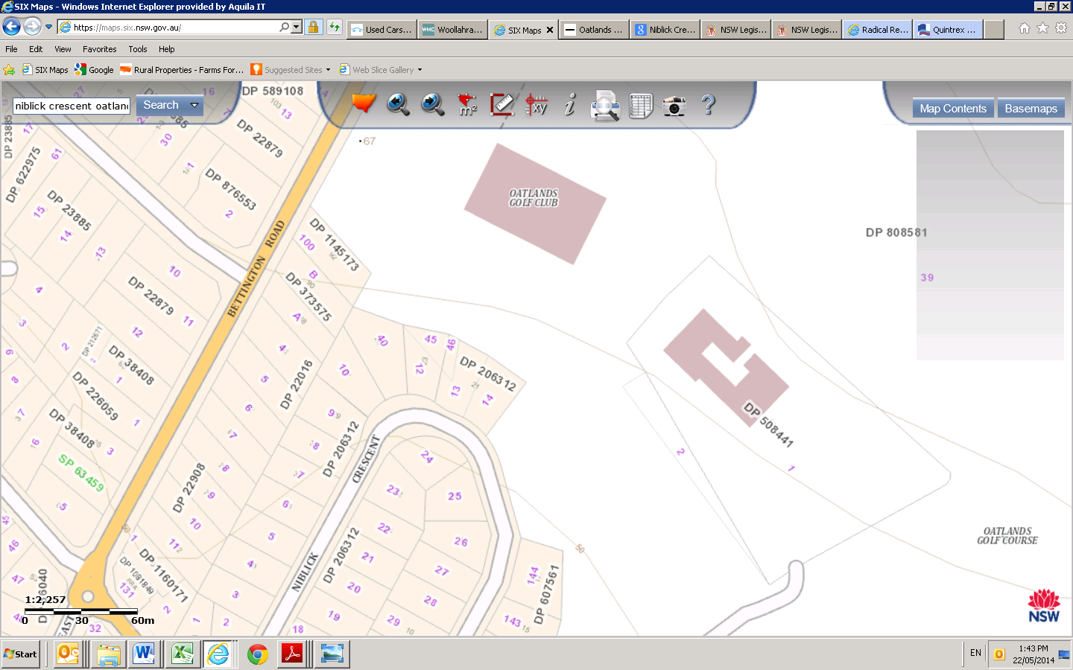

Subject site

Heritage Item, Oatlands House

Location of Subject site and Oatlands House

The environmental effect of the planning proposal that has been identified is the impact upon surface water from the Golf Course and associated carparking areas.

The original detailed technical hydrological investigation has been amended and a copy of this study is attached to this planning proposal.

The amended hydrological investigation has taken into account the changes to the catchment as a consequence of drainage works to Oatlands House and has provided additional information on the overland flow and concludes that the proposal, if constructed in accordance with the recommendations of the report, will significantly reduce stormwater discharges from the subject site.

This submission has been drafted in response to a number of strategies, particularly the NSW Governments’ Metropolitan Strategy (2005), the draft West Central Subregional Strategy, and Parramatta Council’s Residential Development Strategy.

**INDICATIVE TIMELINE**

The following timeline is proposed-

1. 1. Commencement and completion dates for public exhibition period-
2. January/ February 2016
3. 2. Timeframe for consideration of submissions – February /March 2016

3. Timeframe for the consideration of the proposal post exhibition – April/May 2016

4. Anticipated finalisation –December 2016.

# **CONCLUSION**

The proposed inclusion of the subject site within the R2 Zone surrounding the site and imposing planning controls identical to the surrounding locality will ensure that future development of the subject site is consistent with community expectations in terms of building type, size and configuration as expressed within the Parramatta Local Environmental Plan 2012 and that any subdivision of the subject site will facilitate a reduction in overland flow in accordance with the attached Overland Flow Management Study Report.

# **APPENDIX A – OVERLAND FLOW MANAGEMENT STUDY REPORT**